PROJECT 3: Remote Access and VPNs
VOORE. MANI SAI
Computer Networks/ Cyber security
PROF. Merrick Martin
February 28,2023

In this Report we will discuss the most appropriate VPN technology, any other relevant forms of remote and providing a draft report detailing all necessary information.
In present world everything is remotely accessed to secure the access we need to ensure the prevention of unauthorized access and need to have a VPN plan. For this in this paper we discuss the best VPN technology for Corporation Techs along with other forms of remote access that are relevant.
VPN Technology: VPN Technology means which connects the end user remotely to the organization server through secure connection allowing to access the internal network and services. We have Two types of VPN: Internet Protocol Security and Secure Socket Layer/Transport Layer Security VPN.
IPsec VPN: It is a technology that secure the IP Packets of each communication section by authenticating and encryption. For this we need to install VPN on each user devices to establish a secure pathway to the organization servers. The unique about the IPsec is the level of encryption used for securing make hackers to intercept and decrypt the data.
SSL/TLS VPN: This is also a type of protocol where we need not to install any VPN on Client side for having a communication between remote user and server. SSL/TLS VPN can accessible via web interface browser which is a great choice for the end user because it is flexible in terms of device accessing and easy to deploy.
After researching both VPN, it is recommended to use SSL/TLS VPN as a Transmitting medium for a Corporation Techs. The reason is which is easy to deploy, accessible and secure. The deployment is easy because no need have any storage for installing a VPN. We can access through web browser from any device which has a internet connection and even it secure because uses a SSL protocol is widely used in the industry known as Secure against snooping attacks.
Other Forms of Remote Access
Apart from the VPN Technology we have other way of accessing the network and services. These forms are:
- Virtual Desktop Infrastructure where it allows user to access the complete desktop environment from any other device. VDI has a Citrix and VMware where it can access the remotely from anywhere with internet connection.
- Terminal Services: which allow user to access data, application and network resources remotely from a centralized server.
- Cloud-Based Solutions: Platform like amazon, azure, google offers flexible of providing a access to their virtual machine and application making them ideal for remote user.
- Remote Access VPN: For secure connection for internal network and services remote access VPN requires a advance secure control mechanism like two-factor authentication.
- Mobile device management: For managing and securing the mobile devices used by end users we need to use workspace in which it has features like remote wipe, app management and encryption. Below is the Network Design for remote access.
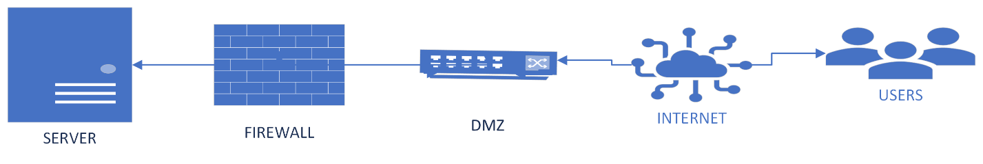

Draft Report:
Introduction:
The remote access plays a critical role in productive and competitive in digital world. Remote access allow employees to work anywhere irrespective of location and anytime which is important in todays world. However remote access has few vulnerabilities to mitigate risks security we need to implement a VPN plan in remote access mechanisms. In this report will recommend the best VPN technology and other forms of remote access that are relevant to corporation techs.
VPN Technology:
After detailing the technology of both VPNs it is recommended to use a SSL/TLS for a Corporation tech. Because it provide a features like easy accessibility, deployment, and security which makes best use for remote access. The working mechanism is which encrypts the data between the end user and server in the internal network to ensure that whatever data transferred is protect from data snooping. Remote users can simply access the portal through web browser no need any installation of specific software on devices.
Others Forms of Remote Access:
Apart from VPN technology we also have other form for a remote access which also allows to access the internet network and their services. The forms are VDI-which provides a centralized desktop environment which can be managed and updated by IT employee. Remote Access VPN-It need an installation on VPN client, but it needed an advance access control such as 2 factor authentication for an organization. MDM- which manages the mobile devices and secure the device by providing encryption algorithm and remote wipe etc.
Conclusion:
By using the SSL/TLS and remote access forms we can plan as per requirements to allow a secure remote communication to the internet network and its services. By implementing in organizations techs, we ensure their employees stay productivity and competitive which also mitigate the security risks.

References
What is a VPN: Everything you need to know about Virtual Private Networks in 2023. (2023, Janauary 20). Retrieved from TechRadar: https://www.techradar.com/news/what-is-a-vpn
What is the Facebook Platform? - Definition from Techopedia. (n.d.). Retrieved from Techopedia.com: https://www.techopedia.com/definition/27916/remote-desktop-services-rds

